Edward Venator and Chris Dickey (Lab 8)

## 555 Performance

|  |  |  |  |  |  |
| --- | --- | --- | --- | --- | --- |
| Parameter | Conditions | Limits | | | Units |
| Min | Typ | Max |
| Timing Error, Astable  Frequency  Drift with Supply | RA = 1k, RB = 3.9k  C = 2.2nF  Vcc = 5-15V | 57.8 |  | 59.5  .29 | kHz  %/V |
| Output Voltage  Output Lo  Output Hi | 0-200mA Load  Vcc=5.1V  Vcc=15.1V  Vcc=5.1V  Vcc=15.1V | 3.55 (Load)  13.0 (Load) | 312(0 load)  875(0 load)  4.58(0 load)  14.3(0 load) | 750 (Load)  1500 (Load) | mV  mV  V  V |
| Max Astable Frequency | RA = 1k, RB = 0  C =2.2nF |  |  | 427 | kHz |

## Monostable Performance

(Tested at 1V increments from 5V – 15V)

Max Pulse Width = 1.065ms

Min Pulse Width = 1.010ms

Variation = 5%

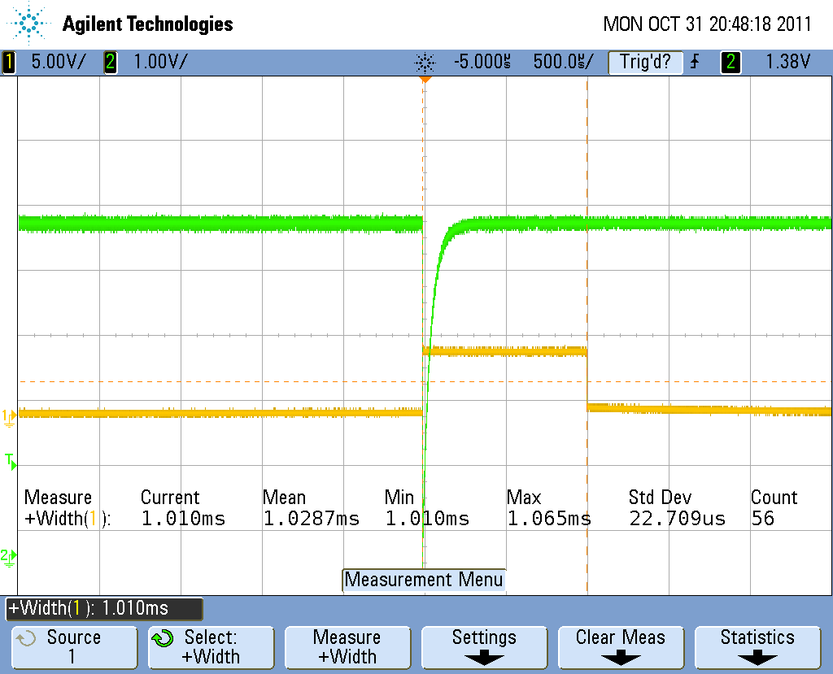

## 555 Astable Raw Data

|  |  |  |
| --- | --- | --- |
| Test | IC | Ours |
| Unloaded (5.1V supply) | -100mv (lo)  4.46V (hi) | 312mV (lo)  4.58 (hi) |
| Sinking Through 25Ohm | 1.875 (lo)  5.0V (hi) | 750mV(lo)  5.0V (hi) |
| Sourcing Through 25Ohm | -100mV (lo)  3.23V (hi) | 0V (lo)  3.55V (hi) |
| Unloaded (15.1V supply) | 60mV (lo)  14.68V (hi) | 875mV (lo)  14.3V (hi) |
| Sinking Through 75Ohm | 1.9V (lo)  14.9V (hi) | 1.5V (lo)  14.9V (hi) |
| Sourcing Through 75Ohm | 0V (lo)  12.8V (hi) | 0V (lo)  13.0V (hi) |